Data Center and Cloud Computing: Labs

Lab5: Observing Flow Table Overflows

1. Objectives

- Fully understand the operation of OpenFlow and observe the operations. - Learn basic skill of configuring an OpenFlow Switch.

- Trigger and observe the behavior of flow table overflow.

2. Equipment Needs

- Three Computers

- A Pica 3290 switch

3. Experiments

3.1 Preparation

- Choose one controller stack from below to complete the rest of this lab Ryu OpenFlow tutorial: http://osrg.github.io/ryu-book/en/Ryubook.pdf

Beacon OpenFlow tutorial http://archive.openflow.org/wk/index.php/OpenFlow_Tutorial#Create_Learning_Switc h

OpenDaylight controller developing wiki:

* Note: this controller stack is quite complicated. As a starter at programming, I do not suggest you use it. But anyone realizing this project using ODL controller gets bonus points. http://www.projectfloodlight.org/getting-started/
3.2 Observing the table overflow in OVS

- The setup of the testbed is shown in Fig. 1.

hping3 is a traffic generator program which we will use on h1. It can generate tcp traffic with different tcp-ports.

By generating traffic, h1 will send traffic with <srcIP=10.0.0.1, dstIP=10.0.0.2, srcPort=X, dstPort=Y>, and h2 will reply with <srcIP=10.0.0.1, dstIP=10.0.0.2, srcPort=Y, dstPort=X>

To enable the traffic to go through, the OpenFlow Controller is programed to install 4-tuple flows. For instance, for X=2000, and Y=4000, 2 flows needs to be installed onto the switch:

<srcIP=10.0.0.1, dstIP=10.0.0.2, srcPort=2000, dstPort=4000, actions = fwd to port2>

<srcIP=10.0.0.2, dstIP=10.0.0.1, srcPort=4000, dstPort=2000, actions = fwd to port1>

We will set the flow table to have capacity of holding flow_limit=100 rules. Therefore we shall receive flow table overflow error message as we installed more than 50 flows (bidirectional).
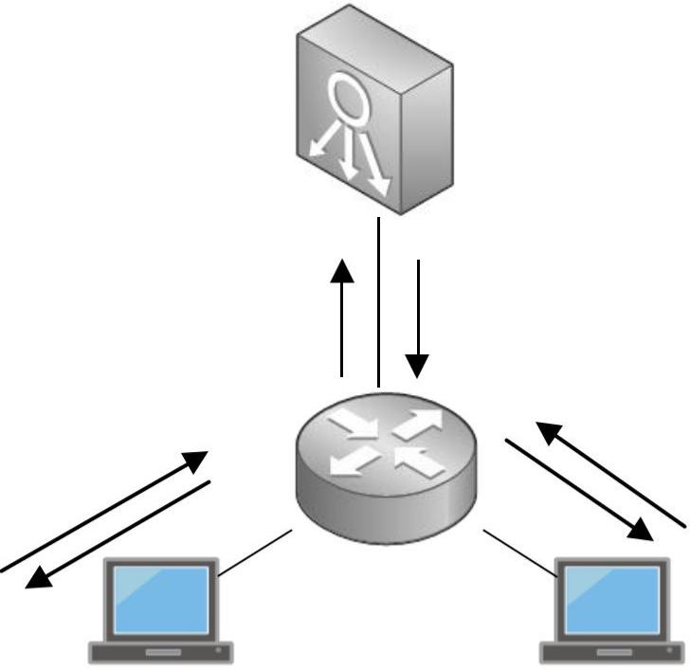

 |  |  | OpenFlow | Controller
 |  |  | Packet | Sr cI P: | 10. 0. 0. 2
 |  |  | Packet | Ds t I P: | 10. 0. 0. 1
Sr cI P: | 10. 0. 0. 1 |  | Mi s s | Ds t I P:
Sr cI P: |  |  | Mi s s | Sr cPor t : |  | Y
Ds t I P: | 10. 0. 0. 2 |  |  |  |  | Y
Ds t I P: |  |  |  | Ds t Por t : |  | X
Sr cPor t : |  | X |  |  |  | X
Ds t Por t : |  | Y | Por t 1 | Por t 2
 |  |  |  | s1
hpi ng3 t r af f i c |  | h1 |  | h2
gener at or |  | h1 |  | h2
 |  | 10. 0. 0. 1 |  | 10. 0. 0. 2

Fig 1. The setup of the testbed

2. Install mininet, hping3

3. Use mininet to setup an OVS connecting two hosts as Fig.2
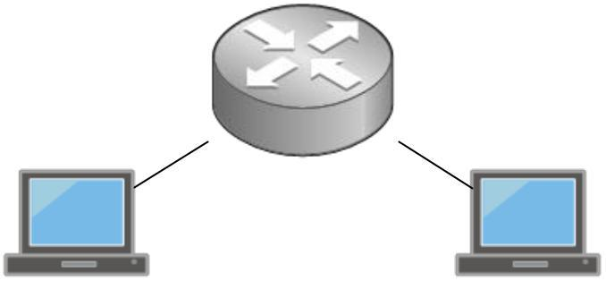

s1

h1 h2
10. 0. 0. 1 10. 0. 0. 2

Fig.2 Topology

4. Connect the controller to the switch

- Add a table to the bridge and limit its capacity

Tip here, to add a new table use “ovs-vsctl” with “add bridge” command. Reference: http://openvswitch.org/cgi-bin/ovsman.cgi?page=utilities%2Fovs-vsctl.8

- Program the controller : Note: Step 6 and Step 7 are actually joined, you may have to go back and forth to debug your program. Read both steps carefully and then start programming.

Program the controller to satisfy the 4-tuple caching so that the flows can be established. Tips:

  - You can start with simple learning switch example in RYU or Beacon. But using that program won’t satisfy our needs.

  - You must refer carefully to the OpenFlow standards and Controller Documentations

  - For setting up TCP flows, nw_protocol and dl_type fields are necessary to be included besides TCP src/dst ports. dl_type specifies that the packet is in IP format and nw_protocol specifies the packet is using TCP as layer 4 protocol.

- Observe the table overflow in OVS
4. Lab Report

1. What is the command for setting the flow-table size in Open vSwitch. Please explain the meaning of each option.

The command for setting the Flow Table size can be seen as follows:

sh ovs-vsctl add bridge S1 flow_tables 0=@ubuntu -- --

id=@ft create Flow_table flow_limit=100 overflow_policy=refuse

- Here sh is for telling Mininet to run the command in the shell that is in the Ubuntu terminal.

- ovs-vsctl is the main command to be executed.

- The part add bridge S1 flow_tables 0 is for directing Mininet to add a Flow Table to bridge S1. The number for the table is to be 0.

The =@ubuntu -- --id=@ubuntu part is the user installing the entry that is ubuntu.

  - The part create flow_table flow_limit=100 creates the Flow Table with Flow Entry limit as 100.

  - The overflow_policy=refuse specifies the action to be taken after an overflow has occurred.

- Submit the snapshot showing that the table is configured to a bounded size.
Ans:
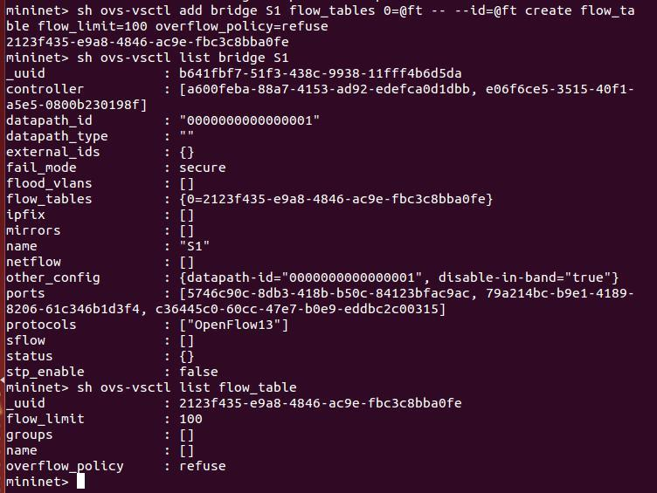
3. Submit the snapshot when you receive table overflow message sent by the controller.

Ans:
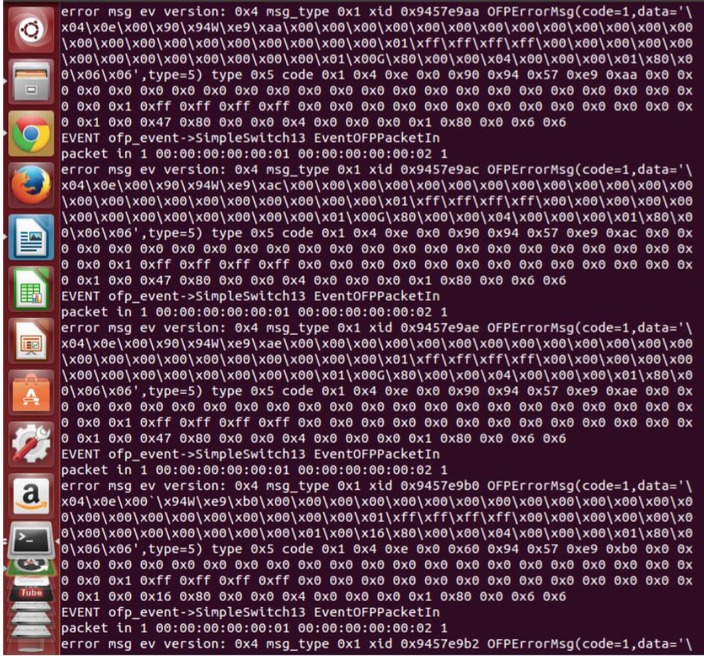
- Submit the PacketIn event call back method of your controller script. Add comments to clarify the logic if necessary.

Ans:

@set_ev_cls(ofp_event.EventOFPPacketIn, MAIN_DISPATCHER) def _packet_in_handler(self, ev):

msg = ev.msg
datapath = msg.datapath ofproto = datapath.ofproto

parser = datapath.ofproto_parser in_port = msg.match['in_port'] pkt = packet.Packet(msg.data) dpid = datapath.id

self.mac_to_port.setdefault(dpid, {})

eth = pkt.get_protocols(ethernet.ethernet)[0] dst = eth.dst

src = eth.src

self.logger.info("packet in %s %s %s %s", dpid, src, dst, in_port)

# learn a mac address to avoid FLOOD next time. self.mac_to_port[dpid][src] = in_port

if dst in self.mac_to_port[dpid]:

out_port = self.mac_to_port[dpid][dst] else:

out_port = ofproto.OFPP_FLOOD
actions = [parser.OFPActionOutput(out_port)]

- install rules with IP and TCP information flag = 0

if (eth.ethertype == ether.ETH_TYPE_IP): ipv4_pkt = pkt.get_protocol(ipv4.ipv4) if (ipv4_pkt.proto == 6):

flag = 1
ip_src = ipv4_pkt.src ip_dst = ipv4_pkt.dst
tcp_pkt = pkt.get_protocol(tcp.tcp) tcp_srcp = tcp_pkt.src_port tcp_dstp = tcp_pkt.dst_port

- install a flow to avoid packet_in next time if out_port != ofproto.OFPP_FLOOD:

if (flag == 0):
match = parser.OFPMatch(in_port = in_port, eth_dst = dst)

if (flag == 1):
match = parser.OFPMatch(in_port = in_port, eth_dst = dst,

eth_src = src, eth_type = ether.ETH_TYPE_IP,ipv4_src = ip_src,ipv4_dst =

ip_dst, ip_proto = inet.IPPROTO_TCP, tcp_src = tcp_srcp, tcp_dst =

tcp_dstp)

self.add_flow(datapath, 1, match, actions)

data = None

if msg.buffer_id == ofproto.OFP_NO_BUFFER: data = msg.data

out = parser.OFPPacketOut(datapath=datapath, buffer_id=msg.buffer_id, in_port=in_port, actions=actions, data=data)

datapath.send_msg(out)

5. Consider the implementation of flow table memory in Open vSwitch. What will happen if the table size is not set while millions of flow entries are inserted into the vSwitch?

Ans: The consequence of installing millions of entries into the Open vSwitch can be seen as follows.

- It will exhaust the high speed memory of the machine on which it is instantiated.

- May reduce the delay of going to the controller when a new packet because there is a good chance the relevant rule is already inserted.

- Could reduce the chance of bottleneck at the controller as more flow entries are already installed.

- Keeps more packets in the data plane.
6. Name at least 3 consequences when flow table gets overflowed.

Ans: The consequences of the Flow Table overflowing can be summarized as follows:

- Delay of going through the controller.

- Low memory usage. Saves cost.

- Consumes more controller bandwidth and could cause bottleneck at the Controller.

- Lesser packets in data plane.

- Faster host mobility support.

